Proposed Pin-Out for Dewar-PAX cable, Biasing X + Y Poles

All pairs (#/#) are twisted pairs. The overall finished cable should be 48″ ± 1″ from connector face to connector face.

- 25-pin D-Sub pin out: (viewed from mating face of connector)

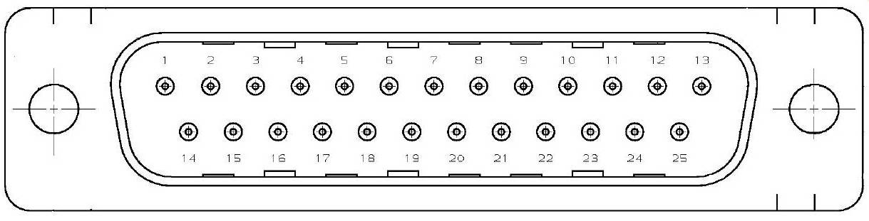

Type | Pins | Function |  | Pins | Function |  | Pins | Function
Case | 1 | Gnd
LNA | 2 / 3 | VdrainY / Gnd |  | 6 / 7 | GateX / Gnd
LNA | 14 / 15 | VminusY / Gnd |  | 8 / 9 | Gnd / VdrainX
LNA | 16 / 17 | Gnd / GateY |  | 20 / 21 | Gnd / VminusX
Other | 4 / 5 | Future |  | 11 / 23 | Future
Other | 18 / 19 | Future |  | 24 / 25 | Future

2. 15–pin Hermetic D-Sub pin out: (viewed from mating face of connector)
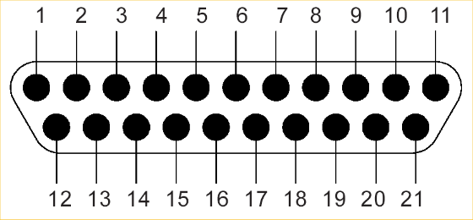

Type | Pins | Function |  | Pins | Function
Case | 1 | Gnd - black
LNA | 2 / 3 | VdrainY-copper / Gnd |  | 6 / 7 | GateX / Gnd
LNA | 12 / 13 | VminusY-red / Gnd |  | 8 / 9 | Gnd / VdrainX
LNA | 14 / 15 | Gnd / GateY-green |  | 18 / 19 | Gnd / VminusX
Dewar temp | 11 / 21 | Temp +/-
Other | 4 / 5 | Future |  | 10 / 20 | Future
Other | 16 / 17 | Future
Colors given for the quad wire inside of the dewar.

